视觉引导机器人动态抓取
Vision guided robot dynamic grasping
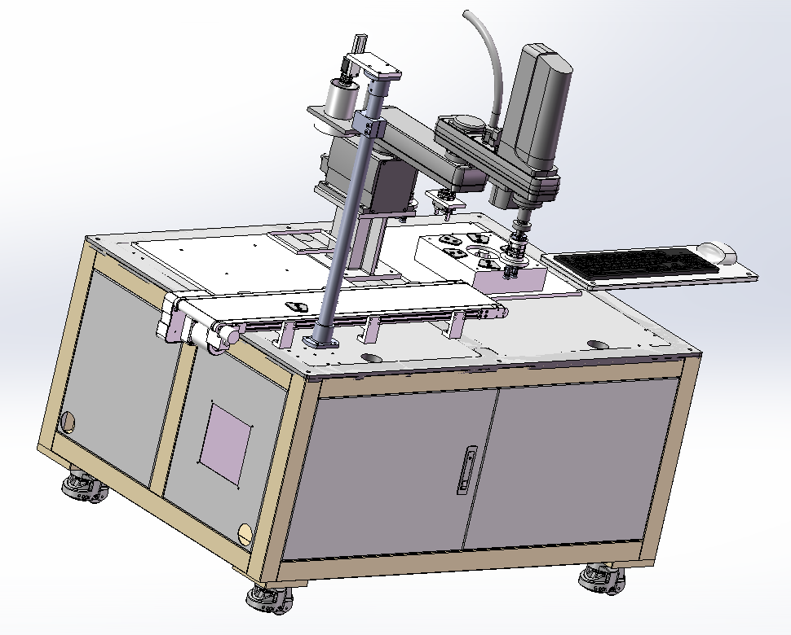
本设备可根据客户实际需求，对生产线产品进行精确定位、调整、抓取、整理、摆放
The equipment can be accurate position, adjust, grasp, collate and place the products of the production line according to the actual needs of customers.。

基于机器人和视觉检测技术开发的机器视觉引导系统，可对较大测量范围内散乱堆放的零件进行定位和拾取。配合工业机器人实现高效智能化的产线，为自动化产线，传送带分拣、组装，自动码垛卸垛以及其他复杂加工等机器人应用提供智能视觉引导解决方案。
The machine vision guidance system based on robot and vision detection technology can locate and pick up the scattered parts in a large measurement range. Cooperate with industrial robots to realize efficient and intelligent production line, and provide intelligent visual guidance solutions for robot applications such as
conveyor belt sorting, assembly, automatic stacking,unloading and other complex processing for production line.

视觉引导机器人系统功能：
(1)通过流水线上的皮带传动，将工件运输到相机的视场内，由于相机处于实时采集状态，当检测到完整的工件进入视场时，完成图像采集。
(2)该系统主要完成对平面上目标工件的识别和定位，为实现对目标工件的准确定位，须在实现目标识别的基础上把相机采集到的工件信息，经过一系列的处理，转化成搬运机器人坐标系下的坐标信息。
(3)在完成对目标的定位以后，须根据目标工件在相机视场内的所处的不同区域，实现机器人对目标工件的抓取，以抓取末端的吸盘真空强度来确认是否完成抓取。
(4)抓取完成后，根据目标工件所匹配的模板不同，分别把工件放置在不同的区域，完成对工件的组装或分类。
Functions of vision guided robot system:
- through the belt drive on the assembly line, the workpiece is transported to the camera's field of view. Because the camera is in the real-time acquisition state, when the workpiece is detected to enter the field of view, the image acquisition is completed.
- the system is mainly used to identify and locate the target piece on the belt. In order to realize the accurate positioning of the target piece, whose information collected by the camera must be transformed into the coordinate information under the coordinate system of the handling robot after a series of processing on the basis of realizing the target identification. (3) after the target positioning is completed, the robot must grasp the target piece according to the different areas of the target piece in the camera field of view, and the vacuum strength of the suction cup at the end of the grab is used to confirm whether the grab is completed.
(4) after the grabbing is completed, the piece is placed in different areas according to the different matching templates of the target piece to complete the assembly or classification of the piece.

工业机器人的视觉引导系统应用包含了以下的几个方面：自动的堆垛和自动卸跺；传送带的追踪；组件的装配；机器人的应用及其检测；机器人上下料；机器人的引导点胶等。通过工业机器人视觉引导系统这几种方面，相机可以通过一次拍摄定位出视野范围内的所有的产品，通过数据传输，引导机器人抓取，并摆放在设定好的位置上。

The application of vision guidance system of industrial robot includes the following aspects: automatic stacking and unloading; tracking of conveyor belt; assembly of components; application and detection of robot; loading and unloading of robot; guiding dispensing of robot, etc. Through these aspects of the vision guidance system of industrial robot, the camera can locate all products within the field of vision through one shot, guide the robot to grab and place them in the set position through data transmission.
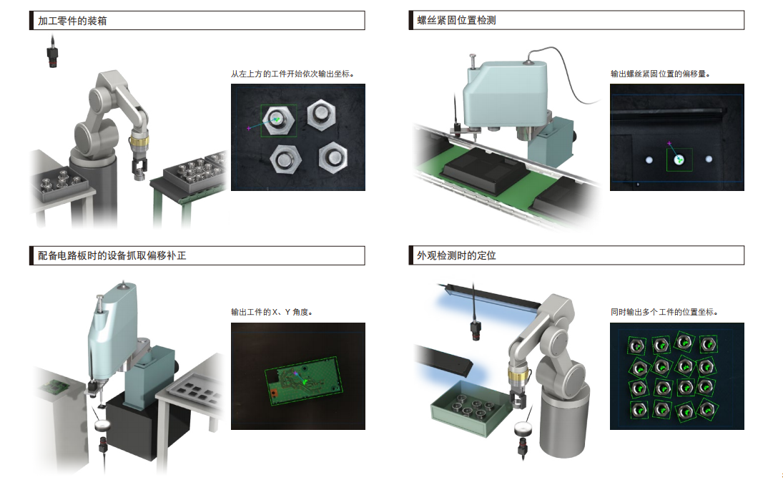
机械手视觉应用示例
传统的机器人只能在预先设定环境下进行离线工作，灵活性和开放性较差，需要设计、制造、安装高精度的工件定位装置，尤其对于轮廓复杂的工件定位，定位装置设计复杂，既降低了定位抓取效率，又增加了应用成本。同时，当工件型号发生变化时，需要重新设计制造定位装置，限制了生产转型周期。基于视觉技术对工件在线识别与定位，利用视觉检测和图像处理的方法，不需要安装高精度的工件定位装置，即可快速、准确地获得工件位置信息，实现机器人对工件的定位和抓取。
The traditional robot can only work offline in the pre-set environment, which has poor flexibility and openness. It needs to design, manufacture and install high-precision workpiece positioning device, especially for the workpiece positioning with complex contour. The design of positioning device is complex, which not only reduces the efficiency of positioning and grabbing, but also increases the application cost. At the same time, when the workpiece model changes, it is necessary to redesign the manufacturing positioning device, which limits the production transformation cycle. Based on the vision technology to identify and locate the workpiece online, using the method of vision detection and image processing, it does not need to install the high-precision workpiece positioning device, it can quickly and accurately obtain the workpiece position information, and realize the robot to locate and grasp the workpiece.
工业机器人的视觉引导系统让整个作业流水线变得灵活而柔性起来，为企业提高了生产的效率。与传统的人工上件相比，节省了人力成本，提高了自动化水平；与超高精度机械定位方式相比，大大降低了对机械定位精度的要求，节省了对机械定位装置的维护成本，且该系统可以兼容多种不同类型，并具备视觉防错功能。
The vision guidance system of industrial robot makes the whole production line become flexible , which improves the efficiency of production for enterprises. Compared with the traditional manual parts, it can save the labor cost and improve the automation level; compared with the ultra-high precision mechanical positioning mode, it greatly reduces the requirements for the mechanical positioning accuracy, saves the maintenance cost of the mechanical positioning device, and the system can be compatible with different types, and has the function of visual error prevention.

